City of Farmington 2025 Stormwater Pond Water Quality
Testing Results and Summary
McKenna Anderson – Water Resources Specialist

Tested Contaminants

Anions
Bromide
Chloride
Nitrate as N
Sulfate

Metals
Arsenic
Barium
Cadmium
Chromium
Lead
Mercury
Selenium
Silver

Microorganisms
Escherichia coli (E.coli)
Total Coliforms

pH / Corrosivity

Herbicides
2,4,5-T
2,4,5-TP (Silvex)
2,4-D
2,4-DB
2-(2-methyl-4 chlorophenoxy)pa
Dalapon
Dicamba
Dichlorprop
Dinoseb
MCPA

Pesticides
4,4'-DDD
4,4'-DDE
4,4'-DDT
Aldrin
Chlordane (Technical)
Dieldrin
Endosulfan I
Endosulfan II
Endosulfan sulfate
Endrin
Endrin aldehyde
Endrin ketone
Heptachlor
Heptachlor epoxide
Methoxychlor
Toxaphene
alpha-BHC
alpha-Chlordane
beta-BHC
delta-BHC
gamma-BHC (Lindane)
gamma-Chlordane

Results

Prairie Waterway Pond
Contaminant Detected | Quantity
Barium | 96.7 ug/L
Bromide | 0.10 mg/L
Chloride | 67.6 mg/L
Escherichia coli (E.coli) | 7.5 MPN/100/mL
pH at 25 Degrees C | 7.8
Sulfate | 23.2 mg/L
Total Coliforms | >2419.6 MPN/100/mL

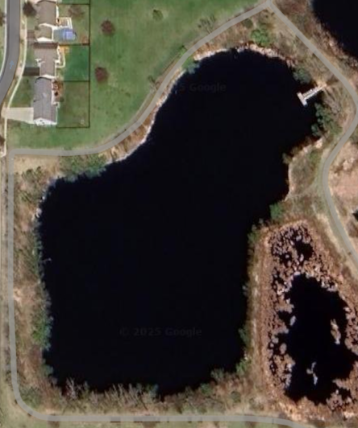
Sapphire Lake Pond
Contaminant Detected | Quantity
Barium | 100 ug/L
Bromide | 0.090 mg/L
Chloride | 79.6 mg/L
Escherichia coli (E.coli) | 1.0 MPN/100/mL
Heptachlor epoxide | 0.085 ug/L
pH at 25 Degrees C | 7.5
Sulfate | 19.1 mg/L
Total Coliforms | 461.1 MPN/100/mL

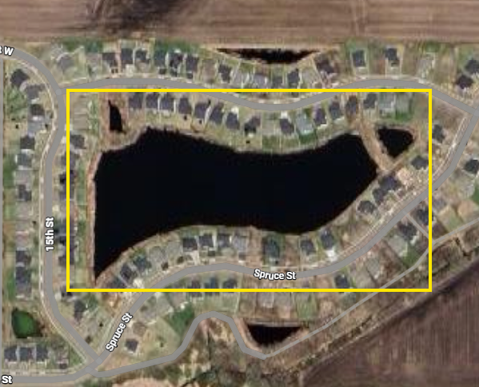

MPN = Most Probable Number (a statistical method that uses multiple dilutions of a liquid sample to estimate the number of microorganisms present.)

Cambodia Ave Pond
Contaminant Detected | Quantity
Barium | 121 ug/L
Bromide | 0.097 mg/L
Chloride | 92.8 mg/L
Escherichia coli (E.coli) | 1.0 MPN/100/mL
pH at 25 Degrees C | 7.2
Sulfate | 22.2 mg/L
Total Coliforms | 1732.9  MPN/100/mL

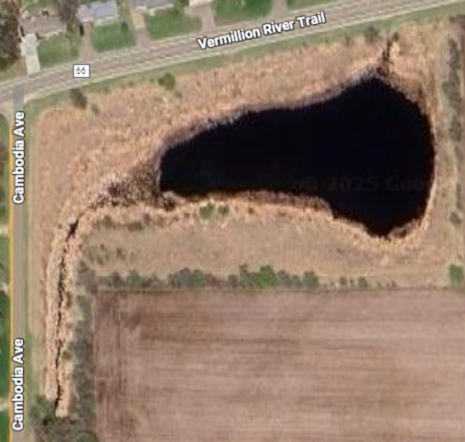
Lake Ann Pond West
Contaminant Detected | Quantity
Barium | 98.7 ug/L
Bromide | 0.082 mg/L
Chloride | 57.1 mg/L
Escherichia coli (E.coli) | 7.2 MPN/100/mL
pH at 25 Degrees C | 7.6
Sulfate | 22.2 mg/L
Total Coliforms | 1119.9 MPN/100/mL

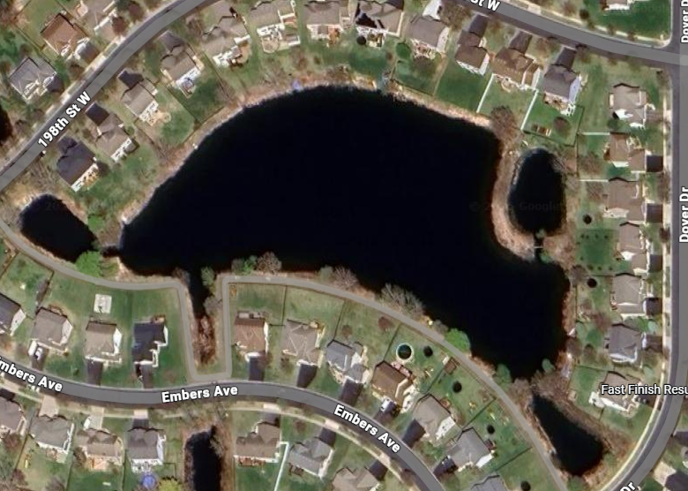

Lake Ann Pond East 1
Contaminant Detected | Quantity
Barium | 70.5 ug/L
Bromide | 0.087 mg/L
Chloride | 62.3 mg/L
Escherichia coli (E.coli) | 5.2 MPN/100/mL
pH at 25 Degrees C | 7.7
Sulfate | 31.1 mg/L
Total Coliforms | 1986.3 MPN/100/mL

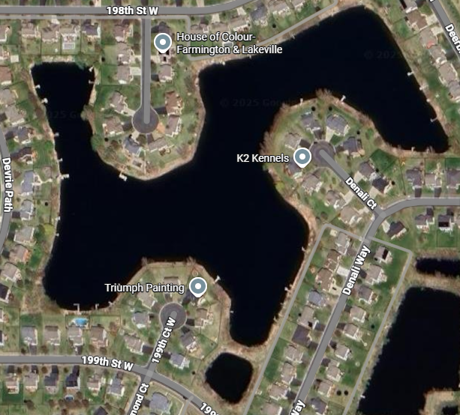

Lake Ann Pond East 2
Contaminant Detected | Quantity
Barium | 61.4 ug/L
Bromide | 0.084 mg/L
Chloride | 59.6 mg/L
Escherichia coli (E.coli) | 35.5 MPN/100/mL
pH at 25 Degrees C | 7.5
Sulfate | 30.1 mg/L
Total Coliforms | 365.4 MPN/100/mL

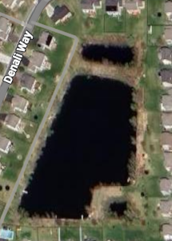

Jim Bell Park and Preserve Pond North
Contaminant Detected | Quantity
Barium | 46.9 ug/L
Chloride | 65.7 mg/L
Escherichia coli (E.coli) | 48.7 MPN/100/mL
pH at 25 Degrees C | 8.2
Sulfate | 5.4 mg/L
Total Coliforms | 488.4 MPN/100/mL

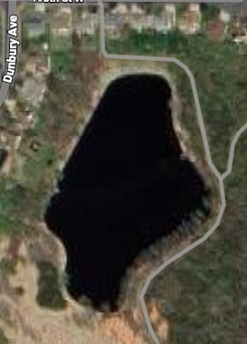

Jim Bell Park and Preserve Pond South
Contaminant Detected | Quantity
Barium | 51.7 ug/L
Bromide | 0.083 mg/L
Chloride | 67.4 mg/L
Escherichia coli (E.coli) | 98.7 MPN/100/mL
pH at 25 Degrees C | 8.2
Sulfate | 10.6 mg/L
Total Coliforms | 387.3 MPN/100/mL

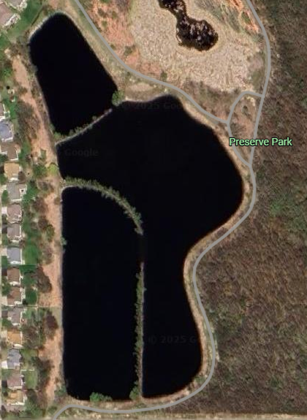

Lake Julia Pond
Contaminant Detected | Quantity
Barium | 70.2 ug/L
Bromide | 0.082 mg/L
Chloride | 70.7 mg/L
Escherichia coli (E.coli) | 185 MPN/100/mL
Nitrate as N | 0.31 mg/L
pH at 25 Degrees C | 8.4
Sulfate | 10.6 mg/L
Total Coliforms | 1986.3 MPN/100/mL

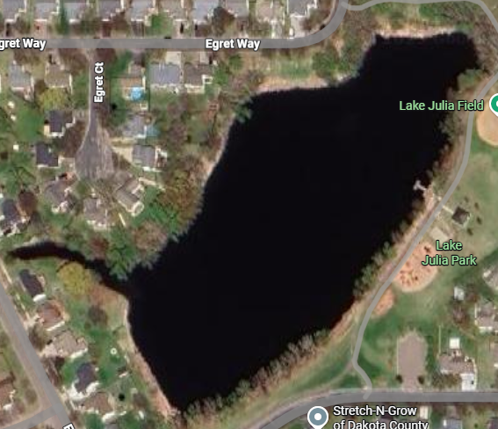

Distad Park and Greenway Pond
Contaminant Detected | Quantity
Barium | 92.7 ug/L
Bromide | 0.093 mg/L
Chloride | 63.7 mg/L
Escherichia coli (E.coli) | 6.3 MPN/100/mL
pH at 25 Degrees C | 8.2
Sulfate | 25.9 mg/L
Total Coliforms | 517.2 MPN/100/mL

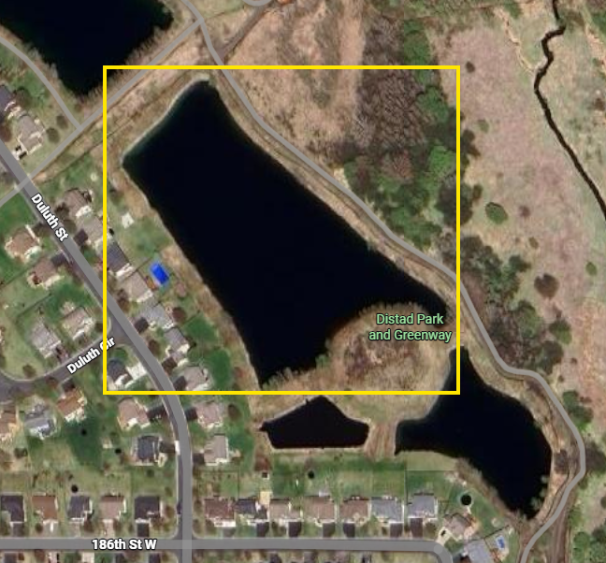

EPA Thresholds

Contaminant | EPA NRWQCMC –  Human Health Criteria | EPA NRWQCMC – Aquatic Life Criteria | EPA NPDWR | EPA NSDWR
Barium | 1000 ug/L | N/A | 2000 ug/L –MCLG/MCL | N/A
Bromide | N/A | N/A | N/A | N/A
Chloride | N/A | 860 mg/L (acute)  230 mg/L (chronic) | N/A | 250 mg/L
*Escherichia coli (E.coli) | N/A | N/A | Zero - MCLG | N/A
Heptachlor epoxide | 0.000032 ug/L | 0.52 ug/L (acute)  0.0038 ug/L (chronic) | Zero - MCLG / 0.2 ug/L - MCL | N/A
Nitrate as N | 10 mg/L | N/A | 1 mg/L – MCLG/MCL | N/A
pH at 25 Degrees C | 5-9 | 6.5-9 | N/A | 6.5-8.5
Sulfate | N/A | N/A | N/A | 250 mg/L
Total Coliforms | N/A | N/A | Zero - MCLG | N/A

EPA = Environmental Protection Agency
NRWQCMC = National Recommended Water Quality Criteria Maximum Concentration
NPDWR = National Primary Drinking Water Regulations
NSDWR = National Secondary Drinking Water Regulations
MCLG = Maximum Contaminant Level Goal
MCL = Maximum Contaminant Level

*The single sampling limits for E.coli set by the EPA for Fresh Waters Designated for Water Contact Recreation (REC-1) shall not exceed 235/100ml
Descriptions of Detected Contaminants

Barium
Barium is a naturally occurring silvery-white metal found in mineral deposits and waterways, typically in relatively insoluble forms such as barium sulfate and carbonate, though more soluble and potentially harmful compounds like barium chloride, nitrate, and hydroxide are also produced through industrial processes. In the environment, insoluble forms tend to persist in soil and water, while soluble forms dissolve more readily and may later recombine with sulfate or carbonate to form stable minerals; however, these soluble compounds pose the greatest risk to living organisms. When ingested, soluble barium compounds can cause a range of toxic effects in both humans and aquatic species, including gastrointestinal distress, muscle weakness, blood pressure and heart rhythm disruptions, and, in severe cases, paralysis or death due to interference with potassium balance.

Bromide
Bromide is the dissolved form of the element bromine and occurs naturally in low concentrations in the environment, though higher levels can result from human activities such as mining, fossil fuel use, oil and gas operations, and certain chemicals. While bromide itself has low toxicity and may even play minor beneficial roles in nutrition, it becomes problematic when it reacts with natural organic matter and strong oxidizers—such as sunlight, chlorine, and ozone—during water disinfection processes. These reactions can generate harmful brominated disinfection by-products, including bromate, certain haloacetic acids, and trihalomethanes, some of which are associated with health risks such as kidney and nervous system effects, hearing loss, and potential carcinogenicity.

Chloride
Though a naturally occurring mineral, chloride – a component of salt - at elevated levels is toxic to freshwater fish, insects, amphibians, and aquatic plants because they disrupt basic cellular processes (such as osmosis), causing water to leave the cells or preventing essential molecules from entering, which can stress or kill aquatic organisms even at lower concentrations. For humans, chloride can degrade water quality, affect its taste, and even increase corrosivity in pipes, potentially mobilizing other contaminants. Common sources of chloride are de-icing salt (used on roads, sidewalks, and driveways), water-softening activities (home water softeners or centralized systems), and fertilizers. When salt and salty brine from water softeners wash into storm drains, lakes, streams, wetlands, or seep into groundwater, the chloride stays dissolved, making it a permanent pollutant. Because chloride does not break down or settle out, once it’s in water or groundwater it’s extremely difficult and expensive to remove, so preventing chloride from entering the environment in the first place is the most effective approach.

E.coli and Total Coliforms
Coliforms are a broad group of related bacteria found in soils, vegetation, surface waters, and the intestines of warm-blooded animals, including humans. Most coliforms are harmless, but some originate from human or animal fecal material and may include pathogenic strains capable of causing mild to serious waterborne illnesses; therefore, their presence in a waterbody can signal fecal contamination and potential health risks. Escherichia coli (E. coli), the predominant fecal coliform species in the gut of warm-blooded animals, serves as an even clearer indicator of sewage or animal-waste contamination when detected in surface water used for drinking or recreation. Although many strains are harmless, some can cause severe illnesses such as diarrhea, urinary tract infections, meningitis, septicemia, intestinal infections, and respiratory illness. For this reason, monitoring E. coli levels is essential, and high counts are used to warn that water may be unsafe for swimming, drinking, or other uses.

Heptachlor epoxide
Heptachlor epoxide is a breakdown product of Heptachlor — a synthetic insecticide once widely used on crops, homes, and buildings. Although heptachlor use was largely banned in 1988, heptachlor epoxide persists in the environment because it dissolves more easily in water than heptachlor and resists chemical and biological breakdown. It can accumulate in soil, water, and sediments, and concentrate in living organisms — including fish, shellfish, dairy animals, and humans — where it stores in fatty tissue and may remain for years. Humans may be exposed to heptachlor epoxide through contaminated food (fish, shellfish, meat, dairy), drinking water, air, or soil. Animal studies have shown that heptachlor epoxide can damage the liver, affect the immune and reproductive systems, and lead to tumors or cancer; because of this, regulatory agencies classify it as a possible human carcinogen. Because of its persistence, tendency to bioaccumulate, and toxicity, heptachlor epoxide remains a chemical of concern for long-term environmental contamination and human health risk

Nitrate as N
Nitrate is a form of the nutrient nitrogen that naturally occurs in soils and water — but when too much nitrate enters lakes, rivers, groundwater, or streams (often from cropland fertilizer runoff, tile drainage, septic systems, wastewater, or manure), it becomes a pollutant with harmful consequences. In aquatic ecosystems, high nitrate levels can be toxic to fish and other aquatic life. Elevated nitrogen levels can also trigger overgrowth of algae and aquatic plants — a process called eutrophication — which depletes dissolved oxygen as algae decompose and can lead to fish kills, reduced diversity of aquatic life, and degraded water quality. For humans, nitrate in drinking water — especially from contaminated groundwater — poses a serious health risk: ingesting water with high nitrate can impair the blood’s ability to carry oxygen, leading to a condition called methemoglobinemia (sometimes called “blue-baby syndrome”) in infants and potentially causing other health issues in sensitive people. Because of these risks — to ecosystems and to public health — reducing nitrate inputs from agriculture, wastewater, and other sources is a major water-quality and health priority in Minnesota.

pH at 25 Degrees C
pH is a measure of how acidic or basic (alkaline) water is, on a scale from 0 to 14, with 7 being neutral. It plays a critical role in water chemistry, affecting the solubility and toxicity of nutrients and contaminants, as well as the health of aquatic ecosystems. Most freshwater organisms thrive within a narrow pH range, typically between 6.5 and 9. Water that is too acidic can dissolve metals and other pollutants, damaging fish gills, impairing reproduction, stunting growth, and sometimes causing death, while water that is too alkaline can similarly stress aquatic life, irritate tissues, and increase the toxicity of compounds like ammonia. pH also influences human health indirectly: water with very low or high pH can corrode pipes, releasing metals such as lead or copper, alter the chemical forms of harmful substances, and affect taste, making water less safe or palatable to drink. Maintaining pH within safe, stable limits is therefore essential to protect both aquatic life and human health, ensuring water remains non-corrosive, chemically balanced, and safe for consumption and recreation.

Sulfate
Sulfates are mineral salts containing sulfur that occur naturally in soil and groundwater and can also enter the environment through decaying organic material and industrial or wastewater discharges. Elevated levels of sulfate can be harmful to aquatic life, but its toxicity varies with environmental conditions. At certain sulfate concentrations, possible adverse effects to species include reduced survival, growth, or reproduction. For humans, when ingested at very high levels, effects can include diarrhea, intestinal pain (especially in babies), dehydration, and slight changes in stomach acidity,

Summary of Results

The stormwater pond water quality testing results indicate generally good chemical conditions, with only nine contaminants detected out of forty-seven tested, and six of these occurring consistently across all ponds. Naturally occurring ions such as Barium, Bromide, Chloride, and Sulfate were present at low and non-significant levels, well below or, in the case of bromide, not subject to any EPA maximum thresholds. Barium concentrations were far under both the EPA NRWQCMC, and Chloride and Sulfate were similarly insignificant relative to applicable guidelines. pH values across all ponds fell squarely within EPA-accepted ranges, and Nitrate, detected only in Lake Julia Pond, remained below regulatory limits. Biological contaminants present a more complex picture: E. coli was detected in every pond, exceeding the EPA’s MCLG of zero for drinking water, though none of the ponds surpassed the EPA’s single-sample limits for recreational exposure, with Lake Julia Pond nearing but not breaching the threshold. Additionally, Total Coliforms were found in every pond, far above the EPA’s drinking water goal of zero. Although Coliforms represent a broad group that can include both harmless and harmful bacteria, their presence signals at least some degree of bacterial contamination, suggesting caution for recreational use. The presence of E. coli and Total Coliforms is not surprising given these ponds’ stormwater inflow, heavy use by waterfowl, and other natural inputs that commonly introduce bacterial communities into surface waters. Levels can fluctuate substantially with changing environmental conditions, making interpretation context dependent. More concerning is the detection of Heptachlor epoxide in Sapphire Lake Pond, a pesticide breakdown product and possible human carcinogen, which exceeded EPA human-health criteria and aquatic-life criteria for acute exposure and surpassed the MCLG of zero. Its presence may be linked to the pond’s historical location within former agricultural lands. Overall, despite the isolated concern regarding Heptachlor epoxide and the expected bacterial indicators, most detected chemical contaminants were minimal, naturally occurring, and of little concern, supporting the conclusion that the ponds exhibit generally stable and acceptable water quality from a chemical standpoint.

Sources Cited
“Bacteria in Surface Waters.” New Hampshire Department of Environmental Services, 2019.
“Chloride.” Minnesota Pollution Control Agency, www.pca.state.mn.us/pollutants-and-contaminants/chloride. Accessed 11 Dec. 2025.
“Coliform Bacteria in Your Water.” University of Georgia College of Agricultural and Environmental Sciences, 21 Oct. 2022, fieldreport.caes.uga.edu/publications/C858-7/coliform-bacteria-in-your-water-2/.
Elphick, James R, et al. “An aquatic toxicological evaluation of sulfate: The case for considering hardness as a modifying factor in setting water quality guidelines.” Environmental Toxicology and Chemistry, vol. 30, no. 1, 1 Jan. 2011, pp. 247–253, https://doi.org/10.1002/etc.363.
“Get Informed | Bromide.” Know Your H20 Water Research Center, www.knowyourh2o.com/indoor-6/bromide. Accessed 11 Dec. 2025.
Hugunin, Angela, et al. “Smart Salting Community Leaders Handbook .” Minnesota Pollution Control Agency, July 2024.
“Nitrogen.” Minnesota Pollution Control Agency, www.pca.state.mn.us/pollutants-and-contaminants/nitrogen. Accessed 11 Dec. 2025.
“Public Health Statement for Barium.” Centers for Disease Control and Prevention, Centers for Disease Control and Prevention, 18 Sept. 2020, wwwn.cdc.gov/TSP/PHS/PHS.aspx?phsid=325&toxid=57.
“Public Health Statement for Heptachlor and Heptachlor Epoxide.” Centers for Disease Control and Prevention, Centers for Disease Control and Prevention, 6 May 2014, wwwn.cdc.gov/TSP/PHS/PHS.aspx?phsid=743&toxid=135.
Sharma, Shailja, et al. “Barium distribution, dynamics and fate in terrestrial and aquatic environments.” Environmental Research, vol. 287, Oct. 2025, p. 123059, https://doi.org/10.1016/j.envres.2025.123059.
“Sulfates.” Wisconsin Department of Health Services, 15 June 2022, www.dhs.wisconsin.gov/chemical/sulfates.htm.
Suter, Glenn, et al. “pH.” EPA, Environmental Protection Agency, 7 Feb. 2025, www.epa.gov/caddis/ph.
Water Science School. “Bacteria and E. Coli in Water.” USGS, 5 June 2018, www.usgs.gov/water-science-school/science/bacteria-and-e-coli-water.

