2025 Farmington, MN:
Assessment of Chloride Levels in North Creek, Middle Creek, and the Vermillion River
Sponsored by Izaak Walton League of America Salt Watch
By: McKenna Anderson, Water Resources Specialist

Introduction
High concentrations of chloride in waterbodies are toxic—and can be fatal—to fish, invertebrates, and some plant species. Elevated chloride levels in drinking water can also harm humans and pets. At high concentrations, chloride disrupts essential cellular processes such as osmosis, causing water to leave cells or prevent vital molecules from entering. This disruption can stress or kill aquatic organisms, even at relatively low concentrations. For humans, excessive chloride degrades water quality, affects taste, and increases the corrosivity of pipes, which can mobilize other contaminants. Although chloride occurs naturally in the environment at low levels, human activities, especially the use of winter road salt, can significantly increase chloride concentrations. After road salt is applied to roads and other paved surfaces, excess salt runs off into nearby waterbodies and can seep into groundwater supplies. Chloride is a permanent pollutant: it does not break down or settle out once it enters water. As little as one teaspoon of salt can pollute five gallons of water. United States Environmental Protection Agency’s recommended water quality criteria for chloride are as follows:
- acute (short-term) exposure is 860 ppm (mg/L), and
- chronic (long-term) exposure is 230 ppm (mg/L).
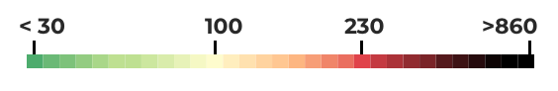
The city of Farmington, MN is interested in testing chloride levels in three separate local waterbodies within the city: North Creek; Middle Creek; and the Vermillion River, for the purpose of determining whether chloride pollution is present. The results will be used to educate and inform the Farmington community about chloride pollution within three of the city’s major waterways.

Methods
Izaak Walton League of America provides free Salt Watch kits that include chloride testing strips with instructions. These kits can be requested through their website which are then sent via mail. Once the kits are obtained, and following the instructions included in a Salt Watch testing kit, a city staff member will visit each of the three waterbodies to collect a water sample and test for chloride. Testing will be conducted at each waterbody four times throughout the year 2025 or once per quarter.
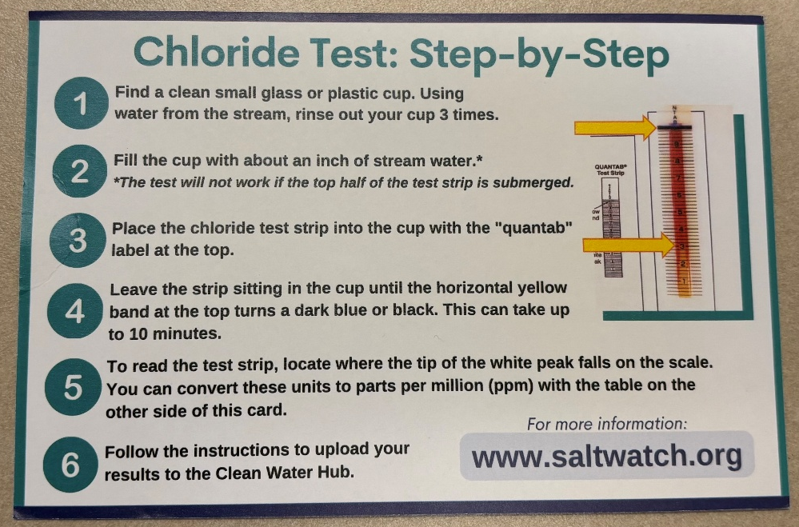
The locations for where testing will occur at each waterbody have been determined by the following factors: located within the city of Farmington limits, located downstream, proximity to a roadway, and accessibility. Below are the designated chloride testing locations for each waterbody:
- North Creek: Intersection at 195th St W, East of Deerbrooke Path
    - Alternative location: West side of Hwy 3 in between building numbers 20265 and 20333
- Middle Creek: East of Akin Rd, North of 206th St W and Devonshire Ave
    - Alternative location: West side of Hwy 3 in between building numbers 20333 and 20415
- Vermillion River: Northview Park, 17 Elm St
Each waterbody will be tested on the same day within each quarter, with results also available on the same day. Results will be manually recorded on paper or electronically at each site and then transferred to the results sections of this document when feasible.

Results
All Chloride levels in the table below are in unit’s ppm (mg/L)
Waterbody | Quarter 1  (2-13-2025) Chloride Levels | Quarter 2  (5-21-2025) Chloride Levels | Quarter 3  (8-21-2025)  Chloride Levels | Quarter 4  (12-11-2025) Chloride Levels
North Creek | 73 | 42 | 42¹ | 73
Middle Creek | 82 | 56 | 49¹ | 64²
Vermillion River | 49 | 42 | 56 | 64

¹ Alternative location was used due to inaccessibility at first location
² Alternative location was used due to ice over conditions on the creek at first location

North Creek:
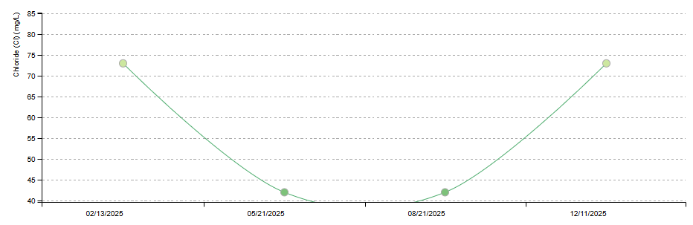

Middle Creek:
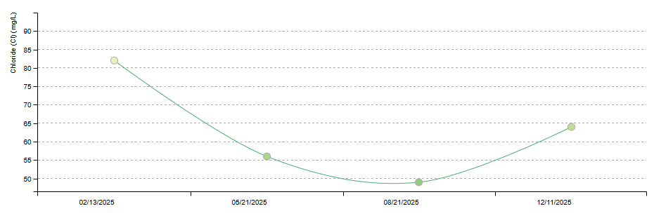

Vermillion River:
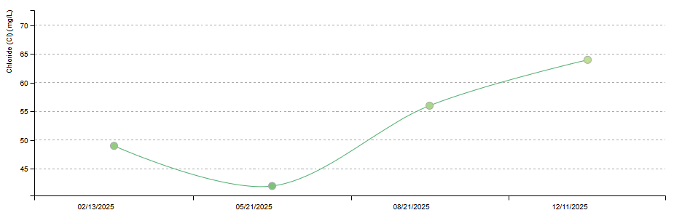

Conclusion
Overall, chloride concentrations in all three monitored waterbodies—North Creek, Middle Creek, and the Vermillion River—remained well below the U.S. Environmental Protection Agency’s recommended water quality criteria. Seasonal patterns were observed, with chloride levels in North Creek and Middle Creek decreasing during the spring and summer months compared to higher winter concentrations. Similarly, chloride levels across all three waterbodies tended to be higher in winter, suggesting some influence from chloride pollution, likely associated with road salt application. In contrast, the Vermillion River exhibited an increase in chloride levels during the summer and winter months, with a slight decrease in the spring. This summer increase may be attributed to delayed chloride release from groundwater storage despite the absence of active road salt application. Given that these waterbodies are characterized by continuous flow rather than stagnant conditions, chloride accumulation is somewhat mitigated. Overall, chloride pollution levels were not substantial enough to indicate significant risk to aquatic life or human health; however, chloride remains a recognized threat to water quality, highlighting the importance of continued preventative measures such as responsible salt use and reduced application during winter months.

Sources Cited
Alms, Eric, et al. “Minnesota Statewide Chloride Management Plan.” Minnesota Pollution Control Agency.
“Chloride.” Minnesota Pollution Control Agency, www.pca.state.mn.us/pollutants-and-contaminants/chloride. Accessed 11 Dec. 2025.
Hugunin, Angela, et al. “Smart Salting Community Leaders Handbook .” Minnesota Pollution Control Agency, July 2024.
Upper Midwest Water Science Center. “Evaluating Chloride Trends Due to Road-Salt Use and Its Impacts on Water Quality and Aquatic Organisms.” USGS, 20 Mar. 2019, www.usgs.gov/centers/upper-midwest-water-science-center/science/evaluating-chloride-trends-due-road-salt-use-and.

